# 2021 - UNIBO – Apple temperature and position datasets

## Treatments

In relation to thermal information of apple fruit (*Malus domestica*), for the “***Apples_Thermocouples_data***” dataset, temperature measurements were taken in 2 different training system*shading treatments:

* **A**: Spindle training system (3.3 m x 1 m planting distances) * Black anti-hail net coverture (15-20% shading). Considered as “Standard Sunburn Susceptibility Situation” (N=4 trees). For spindle trees only different irrigation were applied to test water scarsity effect in sunburn development:
  + Irrigation 100% of the computed ETc.
  + Irrigation 70% of the computed ETc.
  + Irrigation 50% of the computed ETc.
* **P**: Planar Cordon training system (2 m x 3 m planting distances) *Grey anti-hail net coverture (15-20% shading). Considered as “Mid-High Sunburn Susceptibility Situation” (N=3 trees).
  + Irrigation 100% of the compute ETc.

|  |  |
| --- | --- |
|   **A** |   **P** |

Treatments’ conditions: **A** – “Standard Sunburn Susceptibility Situation; **P** – “Mid-High Sunburn Susceptibility Situation”;

The purpose of comparing these treatments was to investigate different environmental conditions in relation to sunburn damage susceptibility, and to try to investigate the effect of water deficit in the appearance of sunburn symptoms. The collection of a wide range of data that can support further modelling and investigations of temperature, fruit position and sunburn damage.

**\*\*Alluminium Foil applications -**  Due to the highly reduced number of fruit developing sunburn nearby the harvest time, Aluminum foils were put underneath fruits monitored with thermocouples in order to stimulate the damage to obtain some data for the later development of prediction model.More information are reported below

### Fruit localization

In this first year of data collection, no information regarding the fruit position were collected.

### Sunburn symptoms evaluation

The sunburn evaluation was conducted by mean of identification of the sunburn damage presence on the fruit monitored during the season (i.e., categorical classification at harvest: damaged / not damaged fruit)

### Fruit temperature and weather data

Local weather data are made available in the files:

* “***Weather_Ext_orchard***” file: including weather data collected outside of the orchard.
* “***Weather_Under_antihailnet***” file: including microclimatic data collected inside of the orchard in trial (with spindle training system).
* * No Microclimatic data for Planar cordon training system were collected.

Fruit temperature data were collected from 14/07 to fruit harvest ??/08. Gala apple fruit were continuously monitored (data resolution 15 min, data presented as hour average) for their temperature using calibrated thermocouples (Tcouple) (model: ‘Type K’ Tcouple, WiNet srl, Cesena – Italy) connected to a wireless sensor network (WSN) (WiNet srl, Cesena – Italy).

For treatments A, P, four highly exposed fruit on each side (east and west) were selected, at medium height, for monitoring their temperature, on 4 different plants (N = 8 per treatment, 2 per tree). For RST treatment the fruit number was doubled (N = 16 on 4 per trees).

Tcouple were fixed to the fruit using medical tape on the back / less exposed fruit side to keep cable in position, while the Tcouple itself was maintained in position thanks to the high cable plasticity. Tcouple was always touching the fruit, without damaging it, as shown in Fig. below. Tcouple was checked 1 – 2 per week for their correct positioning.

Detail of thermocouple mounted on apple fruit

**\*\*Alluminium Foil applications -** Due to the highly reduced number of fruit developing sunburn nearby the harvest time, Aluminum foils were put underneath fruits monitored with thermocouples in order to stimulate the damage. This to obtain data for the later development of prediction model in the SHEET project context. Pictures??? Altro da aggiungere?? Messi quando??

Data collected are available in the “***Apples_Thermocouples_data***” file with the structure presented in the figure below.

Dataset structure

The dataset presents data grouped by treatments represented with a block of 11 columns where the first 7 rows represent the treatments’ condition (*Training, Irrigation)* Presence of aluminum foil to induce the sunburn(A*luminum foil*), *calculation,*  Thermocouple and fruit identifier (*Thcouple_N* ) and Date-time (*Date*).

## Radiation measurements

Data regarding light radiation (“***Radiation measurements***” folder) were collected using an APOGEE SS-110 spectroradiometer, following the scheme reported in the “***Radiation Map***” file inside the paretn folder reported in the figure below. Data collection occurred on 30/06/2021 during a clear sunny day (around solar noon) and was done on a representative Spindle tree ( i.e., “A” treatment; no data collection for P treatments has been done)

Data collection scheme

Per each height (H0-H4 ; n=5 ) and zone (n=3 : 50cm West; Center Trunk ; 50cm East ) of the tree, a set of n.3 measures were taken with the following order: 1st sensor facing up towards the sky; 2nd sensor facing down towards a whiteboard (painted with ???) kept at 20cm distance; 3rd sensor facing down towards the ground. On each west and east side of the canopy a set of data was taken in the inter-row space, , before starting the measurements on the tree, for information regarding the light environment surrounding the tree. Before and after the complete set of tree measurements a set of data was collected outside of the orchard for information regarding the outside.

Data are available in separated files, named as the code reported in the ***Radiation Map*** file, inside the dedicated folder.

# 2023 - UNIBO – Apple temperature and position datasets

## Treatments

# 2022 - UNIBO – Apple temperature and position datasets

### Treatments

In relation to thermal and positional information of apple fruit (*Malus domestica*), 2 main plus 1 preliminary datasets (main: Dataset 1 or “Th.couple_data_2022_timeseries”and Dataset 2 or “SHEET_Th.CAM_HTI_2022”; preliminary: Dataset 3 or “RGBD-T-System_APPLE_Pos&Temp_Dataset”) were produced using different methodologies. For dataset 1 and 2, fruit temperature measurements were taken in 4 different training system*shading treatments (Fig.41). The treatments were:

**A**: Spindle training system (3.3 m x 1 m planting distances) * Black anti-hail net coverture (15-20% shading). Considered as “Standard Sunburn Susceptibility Situation” (N=4 trees).

**E**: Spindle training system (3.3 m x 1 m planting distances) *White anti -hail, -insect, -rain exclusion netting system (40-50% shading). Considered as “Low Sunburn Susceptibility Situation” (N=4 trees).

**P**: Planar Cordon training system (2 m x 3 m planting distances) *Grey anti-hail net coverture (15-20% shading). Considered as “Mid-High Sunburn Susceptibility Situation” (N=3 trees).

**RST:** Spindle training system (3.3 m x 1 m planting distances) * Open field (no netting / shading applied). “High Sunburn Susceptibility Situation” (N=4 trees).

|  |  |
| --- | --- |
|   **A** |   **E** |
|   **P** |   **RST** |

Fig. 41. Treatments’ conditions: **A** – “Standard Sunburn Susceptibility Situation”; **E** – “Low Sunburn Susceptibility Situation”; **P** – “Mid-High Sunburn Susceptibility Situation”; **RST** – “High Sunburn Susceptibility Situation”

The purpose of comparing these treatments was to investigate different environmental conditions in relation to sunburn damage susceptibility, collecting a wide range of data that can support further modelling and investigations of temperature, fruit position and sunburn damage.

For the preliminary Dataset 3, data collection occurred in a different orchard, not in trial, with similar environmental condition as the one of treatment A.

### Fruit localization

The GPS coordinates (Latitude – *‘Lat.’*, longitude - *‘Long.’*, altitude - *‘Alttitude’*) of trees (N=15) carrying fruit under analysis were collected and stored in the file named “GPS_Position_Apple&Tree_SHEET_2022_OK_EPSG4326.xlsx” (Fig. 42).

Fig. 42. ‘Apple_TREE_GPS position’ sheet in “GPS_Position_Apple&Tree_SHEET_2022_OK_EPSG4326.xlsx” file

In the same file, for all the monitored fruit in datasets Tcouple (N=40) and ThCAM (N=108), their position was collected as *X, Y, Z* coordinates, in centimeter, using a standard measuring tape. *X, Y, Z* dimensions were considered respectively as the tree-row plane, the vertical plane perpendicular to the ground and the intra-row tree plane perpendicular to *X* (Fig. 43). Positive and negative values of the coordinates were representing the fruit position in relation to the trunk (coordinate system’s origin), with *Y* = 0 at ground level, +*X* or -*X* values for fruit positioned toward North or South respectively, and +*Z* or-*Z* values for fruit positioned toward East or West respectively, in respect to the trunk origin.

Fig. 43. *X, Y, Z* coordinate system representation; the origin is represented by the trunk, with Y=0 at ground level.

Fig. 44 below shows the file structure for both thermocouple and tagged fruit (i.e., fruit in ThCAM-dataset) position information. In add to ‘*X’, ‘Y’, ‘Z’* coordinates and trees’ GPS coordinates (*‘Lat.’, ‘Long.’, ‘Altitude’*,) and identifier(*‘Plant’*), other information related to treatments (‘*Trattamento’* and *‘TRT’*  ) and internal identifier for tree position and block (*‘Block’* ) are present. *‘ThCouple_Node’* and *‘Th.couple_N’* columns show if the fruit was equipped with a thermocouple (and if so, its number and the mounting node identifier of the WSN), while *‘FruitTAG’* one, represents the unique identifier of each fruit. *‘Side’, ‘Canopy_Height_zone’* and *‘Canopy_Width_zone’* columns represent the East or West side and the zone of the canopy in which the fruit was positioned.

|  |
| --- |
| Thermocouple position   |
| **Tagged fruit position** |

Fig. 44. Example of the structure of the ‘ThCouple_Fruit Position’ and ‘Tagged_Fruit_Position’ sheets present in the “GPS_Position_Apple&Tree_SHEET_2022_OK_EPSG4326.xlsx” file

For preliminary Dataset 3 no fruit positions were collected manually as reference.

### Sunburn symptoms evaluation

For fruits of datasets Tcouple (N=40) and ThCAM (N=108) only, the occurrence of sunburn was evaluated 1-2 times per week (from 64 days after full bloom -DAFB-, occurred on 10th of April, till the harvest occurred on 114 and 120 DAFB – i.e., 02/08 and 08/08 ), so to individuate when first sunburn symptoms appeared (*‘Sunburn Damage’* in Fig. 45). During the season (at 95, 102 and 109 DAFB), also color and chlorophyll degradation information were collected using a Minolta Colorimeter (CR400, Konica-Minolta, Japan) and a DA-Meter (DA-Meter, Sinteleia srl, Bologna – Italy) , on a sample of the fruit in trial (N = 24 to 40 in base of the treatment ). At harvest, a sample of fruit (N = 33 to 51 in base of the treatment) was evaluated again for color *(*i.e., *‘L*(C)’, ‘a*(C)’, ‘b*(C)’, ‘C*(C)’, ‘h(C)’* color coordinates in Fig. 45) and chlorophyl degradation (*‘DA-meter’,* in Fig. *45*), as well as for a more in-detail sunburn damage presence (*‘Sunburn level’,* in Fig. *45*); this to give valuable information for further investigation and modelling of apple sunburn induction and relation with fruit and environmental temperature dynamics. Data regarding sunburn symptoms evaluated both during the season and the harvest are stored in the “Sunburn_data_SB+Minolta+Dameter_2022.xlsx” file, on the ATBCloud (Fig. 45).

Fig. 45. “Sunburn_data_SB+Minolta+Dameter_2022.xlsx” file structure: in add to all the fruit localization information, the file contains the columns shown in the picture and described in the text.

In Fig. 45 above, are shown the sunburn related information, present in the file in add to the positional fruit information already described in Fig. 44. Columns were described in the text above if not for *‘Date’* which represent the date of data collection. Detailed information can be found in the ‘*README-Legend*’ sheet of the described file.

### Fruit temperature and weather data

For all the presented datasets, seasonal local weather data were available and shared (“Weather_data_IN&OUT_Orchards.xlsx” file on ATBCloud).

Fruit temperature data were collected following different methodologies as presented below in each of the dataset description.

### Dataset 1 (Tcouple) – Continuous thermal measurements

From 64 DAFB (14/06) to fruit harvest 114 DAFB (02/08), Gala apple fruit were continuously monitored (data resolution 15 min, data presented as hour average) for their temperature using calibrated thermocouples (Tcouple) (model: ‘Type K’ Tcouple, WiNet srl, Cesena – Italy) connected to a wireless sensor network (WSN) (WiNet srl, Cesena – Italy).

For treatments A, E, P, four highly exposed fruit on each side (east and west) were selected, at medium height, for monitoring their temperature, on 4 different plants (N = 8 per treatment, 2 per tree). For RST treatment the fruit number was doubled (N = 16 on 4 per trees).

Tcouple were fixed to the fruit using medical tape on the back / less exposed fruit side to keep cable in position, while the Tcouple itself was maintained in position thanks to the high cable plasticity. Tcouple was always touching the fruit, without damaging it, as shown in Fig. 46. Tcouple was checked 1 – 2 per week for their correct positioning. This dataset was uploaded on the ATBCloud as “Th.couple_data_2022_timeseries.xlsx” file.

Fig. 46. Detail of thermocouple mounted on apple fruit

Fig.47 Tcouple dataset structure

The dataset presents, per each treatment, the structure shown in Fig. 47 above: From row 1 to 5, are reported information related to treatment (*‘TRT’*), WSN node utilized (*‘ThCouple_Node*’), mounting ‘*Side’* (row 3 – East or West) and *‘Canopy_Widht_zone’* (row 4 – external or internal) of the Tcouple on the tree. Row 6 report the “*Date*” and “*time*” columns of the timeseries, while columns “*1*” to “*8*” represent the hour average of fruit temperature, in Celsius degrees, recorded each of the 1-to-8 mounted Tcouple. Fruit positions were not included in this dataset directly, as well as sunburn damage, but they are stored in the different files described above, which can be linked by the unique *ThCouple_Node*’* ‘*Th.couple_N’* values .

### Dataset 2 (ThCAM) – Discrete thermal measurements.

This dataset was created manually measuring fruit temperature of 27 tagged fruit in each of the A, E, P and RST treatments. In each treatment, the 27 fruits were chosen, on three plants (9 per plant), at 3 heights (low -mid- high) and 3 canopy positions (west side -inner part -east side). The total number of monitored fruit was 108.

Fruit temperature data were collected 5 times during the 2022 season (93, 101, 112, 119 and 131 DAFB). Per each time, temperature collection occurred three times per day (morning -midday -afternoon) in a time window of 1.5h approx. to collect all 108 tagged fruit data.

Temperature measurements were collected utilizing a semi-professional grade thermal camera (HTI–HT-A9, Xintai Instrument Co., Ltd., China; <https://hti-instrument.com/products/ht-a9-thermal-imager>). Temperatures were carefully collected trying to always frame the fruit in the scene center, at 30-50 cm distance max, and placing the thermal pointer to collect temperature on the most exposed area of the fruit, considering its position (Fig. 48).

|  |  |  |
| --- | --- | --- |
|   **HTI Thermal cam** |   **Tagged fruit data collection** |   **Tcouple dataset fruit data collection** |

Fig. 48. From left: Detail of the thermal camera utilized; Detail of temperature collection of a tagged fruit without Tcouple; Detail of temperature collection of fruit equipped with Tcouple.

During these measurements days, fruit of the Tcouple dataset were also measured with the HTI thermal camera to investigate possible correlations or errors between the two utilized sensors (Fig. 48). Considering Tcouple as the reference, the comparison of these sensors resulted with a RMSE (root mean square error) = ±5.04 °C, and a mean error = + 4.14 °C. A regression analysis performed on the collected data showed a R2 = 0.775. The obtained regression model was used to correct the thermal camera reading and resulted in halving RMSE (= ±2.17°C) and nulling the mean error (= +0°C). Further investigations will be done searching for correlation between temperature estimation errors and air temperature which could have altered ThCAM readings.

This dataset was uploaded on the ATBCloud as “SHEET_Th.CAM_HTI_2022.xlsx” file.

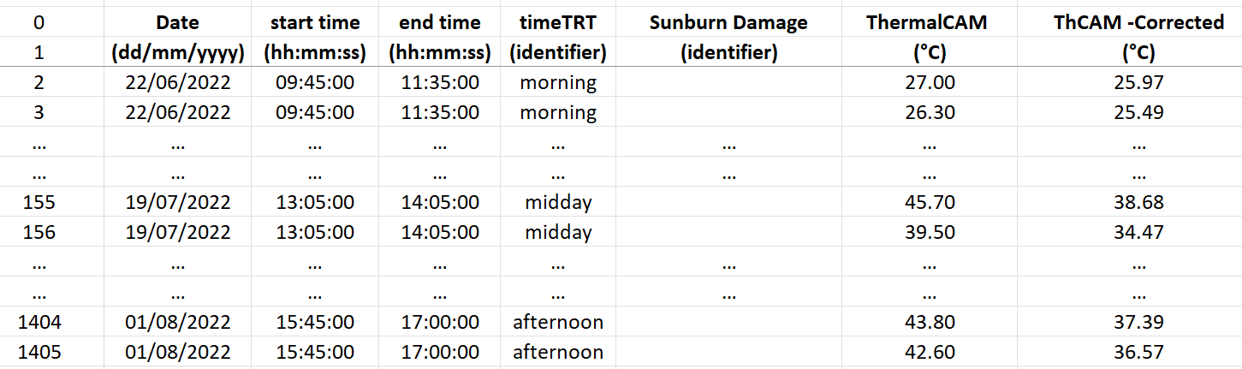

Fig.49 ThCAM dataset structure

in Fig. 49 are shown the adding information to all the fruit localization data described above (Fig. 44), for the ThCAM dataset. *‘Date’*, ‘start time’ and ‘*end time’* show the date and time frame in which fruit temperatures were collected; *‘timeTRT’* represent the timing treatment as morning, midday, afternoon time. *‘Sunburn Damage’* shows when a sunburn symptom was identified in field for the first time (with no classification level). *‘ThermalCAM’* and *‘ThCAM -Corrected’* are respectively fruit temperature values collected with HTI thermal camera and then corrected with the extracted regression aforementioned (i.e., ThCAM vs TCouple). This information can be found in the *ThermalCAM_measurements* sheet of the file.

In the same dataset file, a second sheet is included (called *ThCAM_vs_Thcouple Calib*), where fruit temperature of only those fruit equipped with thermal couple was collected to obtain the just mentioned regression model. In this sheet, in add to the all the columns just presented, *‘T_ThCouple’* shows the temperature recorded by Tcouple for the same fruit and timing of HTI thermal camera measurements; metrics computed between Tcouple and ThCAM measurements are then presented as absolute and percentual errors *(*respectively *‘T_Error (ThCAM-ThC)’* and *‘T_Error%(ThCAM-ThC)’* ), and then the related average errors (*‘meanERR’* and *‘meanERR%’*) and RMSEs (*‘RMSE’ , ‘RMSE%’*). In add absolute error and related average error and RMSE were computed after ThCAM temperature regression correction (respectively *‘T_ErrorADJ(ThCAM-Corrected-ThC’, ‘meanERR_ADJ’, ‘RMSE_ADJ*’).

More in-detail description can be found in the dataset file directly, in the sheet named “*README-Legend*”.

### Dataset 3 (RGB-D/T-system) – Fruit thermal scanning dataset – PRELIMINARY

This preliminary dataset was obtained through the utilization of the RGB-D/T-system developed and presented HERE

To summarize, RGB-D/T-system utilized consist in a sensor fusion platform, based on a depth and a thermal camera, from which were extracted single fruit thermal and positional information. The RGB-D/T system performances resulted in:

* A thermal-to-RGB alignment RMSE / mean error of ±9.17 / +4.5 pixels and ±4.17 / +0.17 pixels, on *x-axis* and *y-axis* respectively;
* A thermal information extraction process presenting a correlation of r > 0.92 compared to the thermal reference at 2.80 m distance and preliminary results on fruit temperature extraction resulted in a RMSE/mean error ranging in between ±3.43 : ±10.36 °C / -0.96 : -9.79 °C, for grape (at 2.30 m distance), and ±1.38 : ±6.72 °C / -0.95 : +6.59 °C, for apples (at 2.80 m distance);
* A preliminary fruit 3D positional error of 0.10/0.15 m approx. at 2.80 m distance.

The presented dataset was obtained for apple fruit not related to the above presented treatments and / or datasets but placed in a similar environmental condition as the treatment A. Since the processing pipeline to align and merge data extracted from both “h1” and “h2” recordings (see “Field data collection with the RGB-D/T system” subchapter, pag. 30) is still under development, data in this dataset are related only to “h1” recordings, where the trunk of the tree was visible in each picture.

The dataset was uploaded on the ATBCloud as “RGBD-T-System_APPLE_Pos&Temp_Dataset.xlsx” file and it includes only information of those fruits correctly detected and that passed all the process filtering steps explained in “Deliverable No D2.2 – Continuation”. In total, 10 out of 12 tree images were correctly analyzed, obtaining thermal and positional information for a total of 46 fruit. The two missing images were not analyzed due to the non-falling in the thermal camera field of view of the detected fruits and/or no fruit detection at all. A graphical representation of the obtained results is present in Fig. 50, reported below.

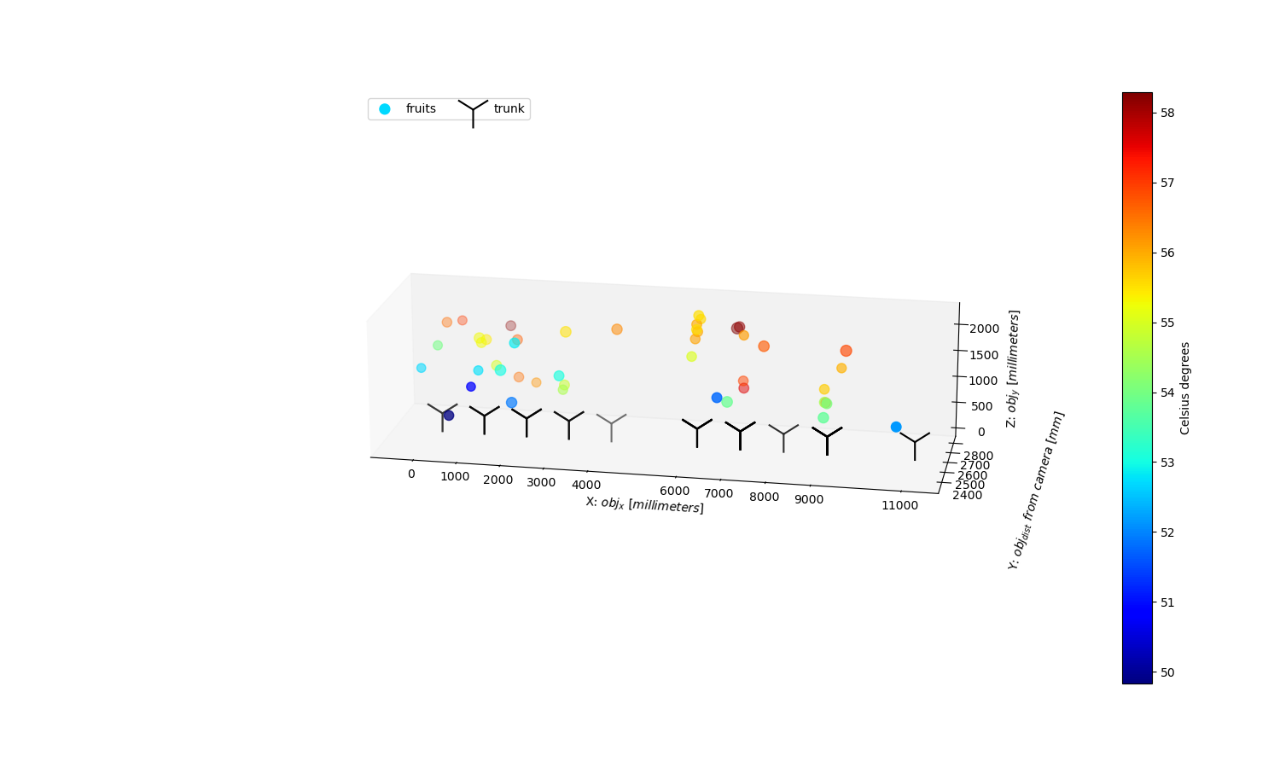

Fig. 50. Copy of Fig. 39 -Apple of the previous chapter, representing apple fruit temperature 3D representation at “orchard level”, with fruit position relative to a defined orchard origin, and temperature represented by color-scale.

As already explained reference data (i.e., actual fruit temperature and position) to test system performances on this datasets were missing due to the late development of the RGB-D/T system; so no performances evaluation for data collected in this dataset can be presented.

Due to the dimension of the dataset, no picture can be presented here, but the RGB/T-System dataset is structured in seven different sections (*sec0* to *sec6*) which present, per each detected fruit, what follows:

* *Sec0* presents the *‘name’* of the analyzed image and its internal identifier (*‘ID_tree’*) as well as the *‘label’* classnumber of the object detected by the YOLO algorithm used for fruit detection;
* *sec1* reports minimum (min), mean and maximum (max) temperature directly extracted from the thermal camera after the “D2.2 – Continuation” process (respectively, ‘*Tmin_SEEK’, ‘Tmean_SEEK’,’Tmax_SEEK’*);
* *sec2* reports six different min, mean and max temperature, those result from the distance correction of sec1 data according to each of the two correction equations utilized *(‘_corr_avg’* and *‘_corr_max’);*
* *sec3* contains ‘*X’, ‘Y’, ‘Z’, coordinates* *in* *millimeters(‘_mm’)* relative to an arbitrary orchard origin (of 0,0,0 mm coordinates), both for detected fruitand tree trunk (‘_*trunk_’)* , to work at orchard level scale, plus the *original distance* *measured by the depth camera* (*‘Z_cam_’*) both for fruit and trunk;
* *sec4* presents *X, Y, Z coordinates relative to the trunk* origin (with absolute values) for the analyzed fruit, as well as the trunk origin (i.e., 0, 0, 0);
* *sec5* presents the *X, Y, Z relative ranges* used to convert the fruit localization from relative to mm , and viceversa, allowing also the change between single tree and orchard scale level;
* *sec6* shows additional information as tree side of data collection (‘*Tree_wall’* – east or west), the cardinal orientation toward the X-axis *(‘Card_dir’*) and a preliminary estimated fruit size (*'Estim_fruit_diam_mm’*) useful for further implementation of the system.

A more in-detail description is present inside the dataset file in the ‘*readme’* and ‘*REFERENCE crs’* sheets.

Considering the preliminary testing of the platform (performances reported above), due to the current possible high error of the system (up to ±10.36 °C and ± 0.15 m), we suggest avoiding using data from this dataset to train model for investigating sunburn dynamics. However, this preliminary dataset is presented, and shared, so to have feedbacks for possible improvements and to make other partners able to evaluate it.

